**Name: S.M. ABRAR MUSTAKIM TAKI**

**ID-20301125**

**NS3 LAB**

**Outputs for different data sizes:**

**128**

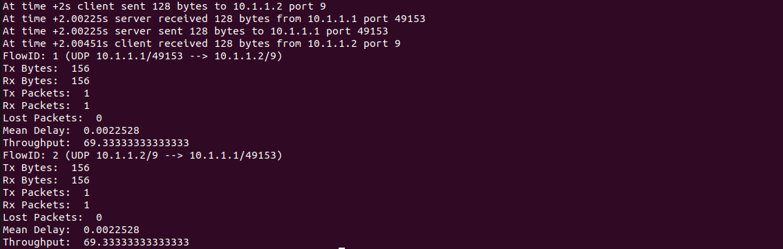

**256**

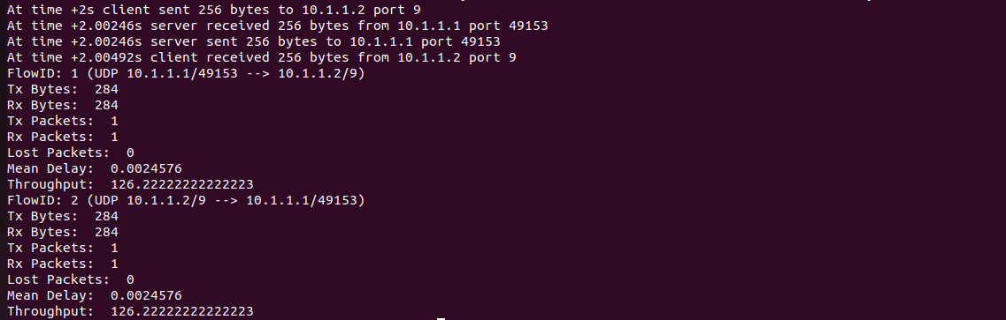

**512**

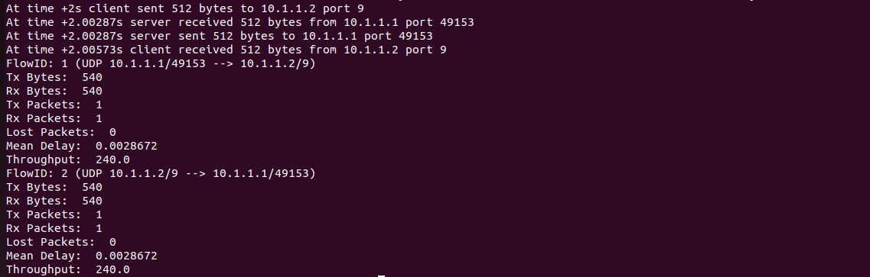

**1024**

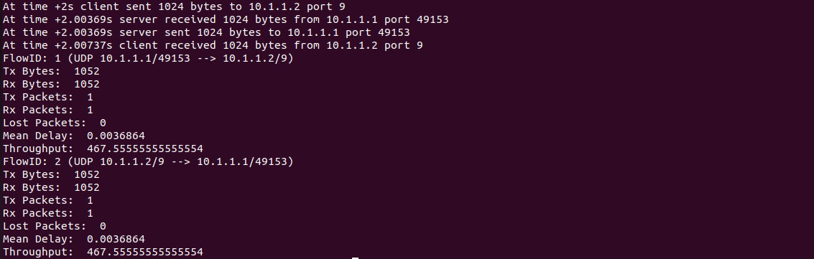

**2048**

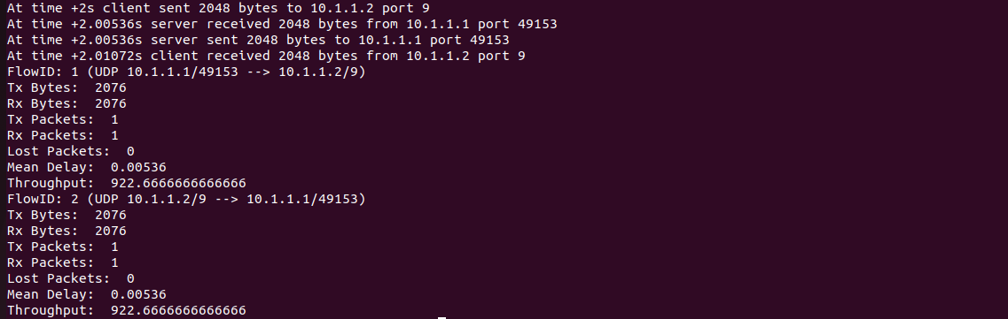

**Graph on Throughput vs Data Size**

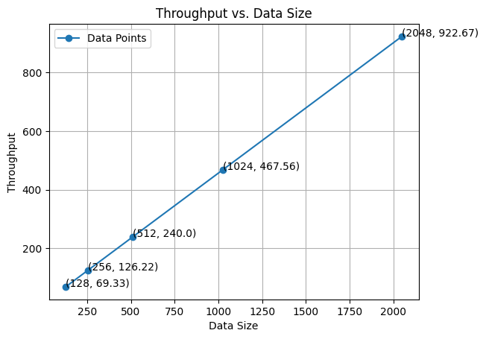

Efficiency and scalability in data processing are often depicted by a graph that demonstrates an increase in throughput as data size expands. When you plot data size on the X-axis and throughput on the Y-axis, it forms a linear correlation. In essence, a computer network displaying a graph of throughput versus data size as a straight-line connection indicates the ability to scale linearly. This means that the network's throughput increases in direct proportion to the size of the data being processed.